Gas Chromatography/Mass Spectrometry
GC/MS

Lotus Consulting presents:

On-Line Siloxanes Measurement System -
SCIONTM SQ GCMS

The Siloxanes Measurement System from Lotus Consulting provides impressive separations and detection of trace volatile polysiloxanes in anaerobic digester and landfill gas samples. The system features the Scion456 Gas Chromatograph with built-in high performance sample concentrator and the SCION™ SQ Mass Spectrometer. The setup is designed to be deployed on-line to monitor hourly siloxanes in the fuel line to a cogeneration power plant to examine near real-time levels. This system also handles both pressurized canisters and Tedlar bags without hardware changes.

The fully automated system is designed to completely resolve nearly all volatile siloxanes from Tetramethyldisiloxane to Dodecamethylhexacyclo-hexane (D6) at levels typically below 0.0001 ppm V/V to over 50 ppm V (400 ml injection and 49:1 split). Samples are loaded through a 16-position automated sampler and trapped onto a low-volume adsorbent trap, with a fixed volume sample loop to ensure accurate volume samples for samples with high levels of methane and carbon dioxide.

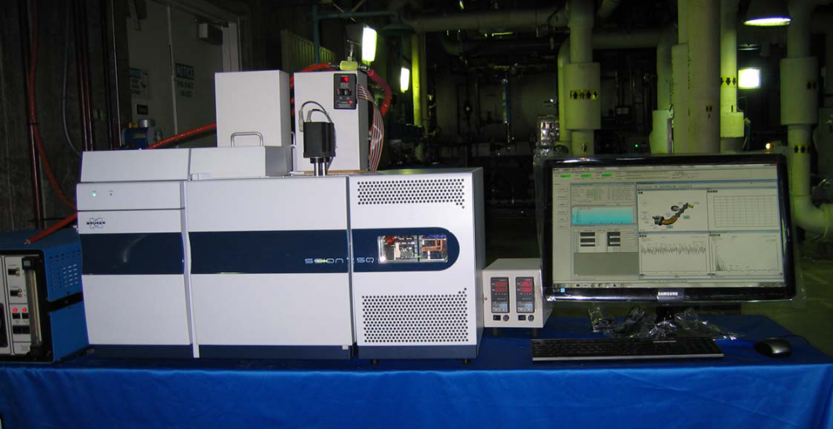
Toxic compounds in the TO15 list are also monitored and reported concurrently with siloxanes. And methane and carbon dioxide concentrations in the fuel are measured, and the BTU value of the fuel gas is computed hourly with an included column set in a separate column oven and thermal conductivity detector.

Detection of volatile polysiloxanes in anaerobic digester and landfill gases is a difficult analysis in gas chromatography. Sticky analytes must be concentrated into a small volume to enhance detection. A very large number of possible organics (>300) must be “fully” resolved to avoid improperly assigning concentrations from overlapping peaks. Identification and detection is facilitated with the extremely sensitive SCION SQ MS. The system involves an air-cooled adsorbent trap, 6 automated valves, two independent column ovens, a thermal conductivity detector, 16-position automated sampler, and one workstation. All of these operations utilize nearly all of the powerful and comprehensive capabilities of the Scion 456, SCION SQ MS and Scion MS Workstation 8.

Solutions to Difficult Analytical Problems…
20
30
40
minutes
0
125
MCps
TMDS
L2
DMTVDS
D4
D5
D6
D3
L3
L4
L5
Typical Chromatogram of Siloxanes in Digester Gas with Selected Ions
Displayed Appropriate for Each Analyte. .

Clean System Blanks
- Multi-layer carbon adsorbents for trap
- No thermal breakdown products
- Maximum temperature limit of 300 ºC
- All valves are heated; limited to 225 ºC max

Efficient Recovery of Light-End Components
- Area reproducibility for Tetramethyldisiloxane - < 6 %
- Accurate control of trap temperature
(< ±2 oC) over complete temperature range
- Self-calibrating platinum probe (RTD)
- Stable control of trap temperature (< ±2 oC)
- Proportional controller
- Close contact between heater, coolant air and trap

Full Recovery of “Heavy” Compounds
- Area Reproducibility of Dodecamethylhexacyclosiloxane
  - < 6%
- All sample lines heated to at least 90 ºC - no cold spots
- Smooth and inert sample lines - electroformed nickel
- Trap desorbing temperatures to 300 ºC
- Maximum trap heating rate - 300 ºC /min

Elimination of Interfering Artifacts
- Multi-bed carbon adsorbent trap
- No thermal breakdown of trap adsorbents that would
yield interfering hydrocarbons (i.e. Benzene with Tenax)

Accurate Measure of Sample Volume
- Sample flow to vent just before trapping
- Stabilizes loop pressure to atmospheric
- Sweeps sample lines with new sample
- Volume-measuring flow path swept with nitrogen
prior to trap heating
- Sample loading independent of sample line or canister pressure

High Concentrations of Methane and CO₂?
- Mass Flow Controller (MFC) not accurate with major portions of methane and CO₂ - MFC usually calibrated for air
- Cannot handle variable gas mixtures properly
- Standard fixed volume sample loop of 400 ml
  - Accurate measure of sample volume
  - even variable mixtures of CO2 and methane

Water Treatment
- Multi-bed carbon absorbents are hydrophobic and do
not trap water at ambient temperatures and are
effective traps for all components on siloxane and
TO15 list
- Allows full recovery of both light-ends and heavies
- Effectively handles water-saturated samples
- Dry purge step time-programmable

…And More Solutions

Minimal Carry-over
- Trap continuously purged with nitrogen
when sample not loading
- Sample lines swept to vent with new sample
just before trapping
- All tubing exposed to sample maintained at elevated
temperatures of at least 90 ºC
- Carry-over « 0.1 % for most analytes

Retention Time Reproducibility
- Reproducible + accurate control of
column oven temperature
- proportional control (PID)
- platinum probe (RTD)
- Typical RT reproducibility - < 0.01 minutes

Quantitation Reproducibility
- Measuring flow path swept with nitrogen
prior to trap heating
- Typical area reproducibility - < 9 %

Monitoring of Operations
- Both analog gauges and digital displays
for column pressure
- Flows/pressures documented in results report
- User-specified temperature limits for all thermal zones
- Visual indication of sample loading
- Complete system status with developing
chromatograms on one screen

Simplified Method Execution
- Single run method contains all
operating parameters for both
GC and MS, including cold trap
(“Injector”), valve actuations
(“Sample Delivery”), compound
table, computation entries and
report formatting. Simply
20
30
40
minutes
0
40
MCps
TMDS
L2
DMTVDS
D4
D5
D6
D3
L3
L4
L5
Typical Chromatogram of Siloxanes in Landfill Gas with Selected Ions Displayed Appropriate for Each Analyte.

activating this single method
sets up the complete system, to
minimize operator errors.

Calibration Standards
- Permeation tubes provided for individual siloxane components
- Variable dilution flow to generate lower concentrations
- On demand creation of siloxane standards

Data Processing
- User can easily view both the developing
chromatogram and MS spectra in real time
- Workstation can perform library searches on peaks in
developing chromatogram for immediate
confirmation of peak ID
- Single stored data file contains raw chromatographic
data, final report, complete run method (including
GC, MS, trap parameters), stream position, run log
and error messages
- Data collection, report generation, system control, and
custom report operate in Windows 7
- View/edit calibration curves
- Batching printing of reports from Windows Explorer
- Multi-level security with passwords
- MS peak names to 40 characters
- Microsoft Excel 2010 standard

Data Integrity
- No overwriting of data files
- Operator cannot change Sample ID after collection
- Operator cannot change Date/Time of injection
- Cannot alter log files after collection
- Cannot change sample notes after collection
- All calibration data is archived with every raw data file
- Message log contains complete listing of system operations
- Instrument run log documents operating conditions
- File names can be labeled with sample ID, injection
date/time, method used and module source as variables
- File names can be up to 255 characters long

Options
- Addition of other detectors, such as Pulsed
Flame Photometric Detector (for sulfur compounds)

System Specifications

Concentrator Traps
- Temperature range: ambient +6 ºC to 450 ºC
- Cooled by compressed air
- Maximum heating rate: >300 ºC/minute
- Maximum cooling rate: typically >400 ºC/minute
- Temperature stability: < ±2 ºC after 1 minute stabilization
- Temperature overshoot: max. <10 ºC, typically <5 ºC
- Multi-layer hydrophobic adsorbent trap – no Tenax
- Trap internal volume: ~600 microliters – adsorbent trap
- Trap setting controlled/monitored through GC with
platinum probe (RTD) and proportional controller (PID)
- Programmable in 24 temperature steps with holds

Automated Sampler
- Standard: 16-position, optional 4-, 6-, 8-, 10-positions
- Micro-electric actuation, self-aligning
- Independently controlled valve oven
- Maximum temperature limit: 225 ºC
- Sample position selected through workstation’s sample list
- Position documented in final report and archived with data
- Sample lines heated through control of system

Valving
- Fully automated under time-programmable control of GC
- Valves mounted in heated enclosures
- Micro-electric actuation, easy realignment
- Valco Series CWE; maximum temperature: 225 ºC
- Valves can be turned on/off 21 separate event times
within single method
- 15 external events available

Sampling
- Configured for real-time measurement of fuel line
- Samples in canisters or Tedlar bags can be handled without hardware changes

Pneumatics
- Temperature-sensitive flow elements maintained at 45 ºC
- Flows automatically adjusted for atmospheric pressure or vacuum

System Performance
- Detection limit: < 0.0001 to < 0.002 ppm V/V (compound dependent) with 400 ml sample volume and 49:1 split with selected ion monitoring
- Typical linear range: <0.0005 to >2,57 ppmV -D6
- Area reproducibility typically < 9 %
- Carry-over « 0.1 %, except D5 and D6
- Typical RT reproducibility - < 0.01 minutes

Column Ovens
- Column oven size: 15.9 liters
- Temperature range: ambient +6 ºC to 450 ºC
- Temperature program rate: 0.1 ºC/min to 120 ºC/min
- Oven cool-down: 400 ºC to 50 ºC in 4.5 minutes
- Programmable in 24 temperature steps with holds
- Secondary column size:
- Secondary column oven isothermal

Mass Spectrometer
- Quadrupole Mass Spec Design with pre- and post-filter
- Mass range: 10 to 1200 Da
- Scan rate: up to 14,000 Da/sec
- Dual filaments, with currents up to 200 µA
- Minimum dwell time: 1 ms
- Transfer line temperature up to 350 ºC
- Source temperature: 100 ºC to 350 ºC
- Mass axis stability: <±0.1 Da over 48 hours
- EI full scan, 1 pg OFN, from m/z 50 to 300 for m/z 272, S/N ≥ 600:1
- Electron multiplier with on-the-fly multiplier gain optimization for Extended Dynamic Range (EDRTM)
- 310 L/sec Turbomolecular pump, air-cooled

Thermal Conductivity Detector
- Constant mean temperature filament design
- Time-programmable range settings: 0.05, 0.5, 5 and auto-zero
- Linear dynamic range: 10⁶ Butane
- Internal cell volume: 140 µl
- Results reported as BTU/SCF

General
- Color touch screen GC display/keyboard
- Ethernet communications between GC and Workstation
- USB communications between MS and Workstation
- Instrument width: 41 inches, including concentrator
- Line voltage for GC: 120 V, 20 amperes;
for MS: 120V, 15 amperes
Lotus Consulting
310/569-0128 Fax 714/898-7461
email ebramstoncook@msn.com

5781 Campo Walk
Long Beach, California 90803
SCION™ and EDR™ are registered trademarks of Scion Instruments

