Gas Chromatography
GC

Lotus Consulting presents:
Sulfur Measurement System (SMS)

The Sulfur Measurement System from Lotus Consulting provides impressive detection of trace volatile sulfur compounds in ambient air samples. The system features the Scion 456 Gas Chromatograph with built-in high performance sample concentrator and a sensitive pulsed flame photometric detector (PFPD). This system handles both pressurized canisters and Tedlar bags without hardware changes.

The fully automated system is designed to detect volatile sulfur compounds. Samples are loaded through an optional 16-position automated sampler and trapped onto a low-volume cold trap with a mass flow controller (MFC) setting the sample size. All sample lines are Silcosteel treated for inertness. A proprietary trap material permits full recovery of the very reactive sulfur gases.

Detection of sulfur compounds in ambient air is very difficult due to the interaction of these chemicals with the common materials normally employed in gas
chromatographic analyses. For example, hydrogen sulfide at low levels is nearly completely lost when exposed to most metal and glass surfaces. Special precautions are required to ensure full recovery.

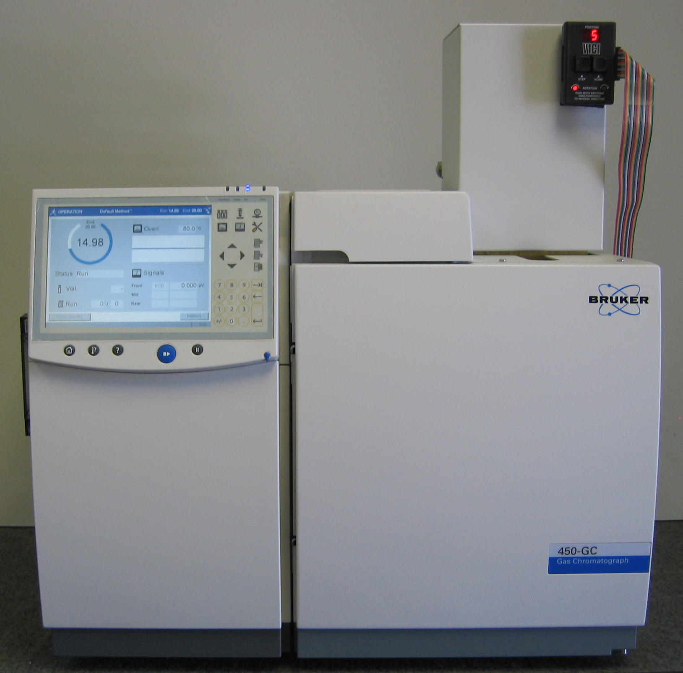
In addition, usual sulfur detectors, such as flame photometric or chemilluminescence, are not sensitive enough to detect ambient levels of sulfur components via direct injections of 1-ml samples. Large volume samples must be concentrated into a small volume to enhance detection, especially with the flame photometric detector, as its response is proportional to the square of the concentration. To enhance response with this detector by a factor of ten, the concentration volume loaded must be increased 100 times. All of these operations utilize nearly all of the powerful and comprehensive capabilities of the Scion 456 and Workstation. Such a complex analyzer requires assurances that the data is valid, that the system is fully functional and easy to use, and that the ultimate performance is achievable.

Solution to Difficult Analytical Problem…

Clean System Blanks
- No thermal breakdown products from trap material
- Maximum temperature limit of 450 ºC
- All valves are heated; limited to 225 ºC max
- Cryogenic cleansing of purge gas – vented after each cycle

Elimination of Interfering Artifacts
- Inert trap standard
- No thermal breakdown that would yield interfering peaks
- Trap temperature limit to 450 ºC

Sharp Chromatographic Peaks
- Minimum distance from trap to column (~15 cm)
- Cryofocus trap isolation during trap heating
- Columns attached directly to final valve
- minimum effect of extra-column volumes at
critical chromatographic point
- Trap volume – ~600 microliters

Accurate Measure of Sample Volume
- Sample flow to vent just before trapping
- Stabilizes MFC
- Sweeps sample lines with new sample
- Volume-measuring flow path swept with nitrogen
prior to trap heating
- Accurate volumes from 5 ml to 2400 ml
- Sample loading independent of canister pressure

Minimal Carry-over
- Traps continuously purged with nitrogen
when sample not loading
- Sample lines swept to vent with new sample
just before trapping
- Carry-over « 0.1 %

Retention Time Reproducibility
- True electronic flow control - not pressure control
- Reproducible + accurate control of
column oven temperature
- proportional control (PID)
- platinum probe (RTD)
- Typical RT reproducibility - < 0.03 minutes

Quantitation Reproducibility
- Column leaks detected with pressure monitoring
- Measuring flow path swept with nitrogen
prior to trap heating
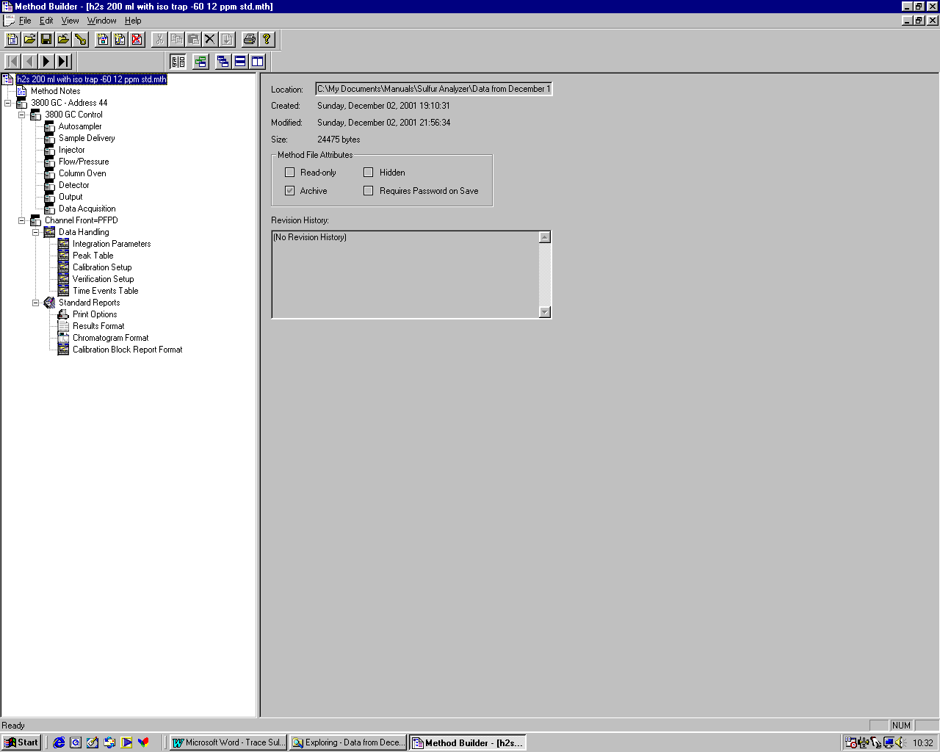
- Typical area reproducibility - < 3 %

Simplified Method Execution

Single run method contains all

operating parameters, including

cold traps (“Injector”), valve

actuations (“Sample Delivery”),

compound table, computation

entries and report formatting.

Simply activating this single

method sets up the complete

system, to minimize operator

errors.

Monitoring of Operations
- True electronic flow control for columns
– not pressure control
- Generated backpressure becomes a diagnostic
- Flow remains constant throughout run
without computations/fudging
- Both analog gauges and digital displays
for column pressure
- Full electronic flow control of all detector gases
- Flows/pressures documented in results report
- User-specified temperature limits for all thermal zones
- Visual indication of sample loading
- Complete system status with developing
chromatograms on one screen

Data Processing
- Single stored data file contains raw chromatographic
data, final report, complete run method stream
position, run log and error messages
- Data collection, report generation, system control operate in Win 7.
- No overprinting of retention times on chromatogram
- Edit/lock calibration coefficients
- View/edit calibration curves
- Batching printing of reports from Windows Explorer
- Multi-level security with passwords
- Peak names to 39 characters; first 12 printed in reports

Data Integrity
- No overwriting of data files
- Operator cannot change Sample ID after collection
- Operator cannot change Date/Time of injection
- Cannot alter log files after collection
- Cannot change sample notes after collection
- All calibration data is archived with every raw data file
- Message log contains compete listing of system operations
- Instrument run log documents operating conditions
- File names can be labeled automatically with sample ID,
injection date/time and module source as variables
- File names can be 255 characters long

Options
- Addition of other detectors, such as Flame Ionization
Detectors with simultaneous detection through a
separate sampling stream
- Pressure station to bring canisters above atmospheric
pressure for proper loadings
- Automatic insertion into SampleList of pressure station
readings before and after pressurization for dilution
corrections
- Canister cleaner with single high capacity, non-oil pump

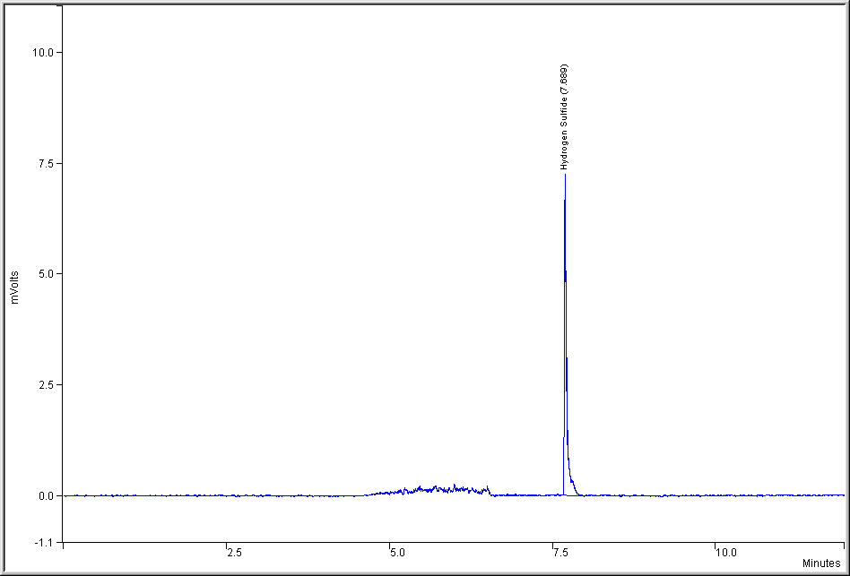
Performance

Typical Chromatogram of
1.5 ppb Hydrogen Sulfide Standard in Nitrogen

Sample volume basis: 200 ml.
Sample is 25 ml loading of 12 ppb standard.
Column: Agilent Chrompak CP-Sil 5 CB, 0.53 mm ID, 30 meters, 5 μ film.
Column temperature: 30 ºC. Column flow: 10 ml/min.
Trap: -160 ºC, hold for 6.1 minutes, ramp to 200 ºC at 200 ºC/min.
Detector temperature: 200 ºC.
Detector range: 10.
Sampling portion of chromatogram: 0 to 6.5 minutes
Chromatography starts at 6.5 minutes.

Instrument – Scion 456 Gas Chromatograph
Detector – Pulsed Flame Photometric Detector (PFPD) with DEFC
Sampling System – Cryogenic Concentrator with Fully Automated Valves
for unattended measurements

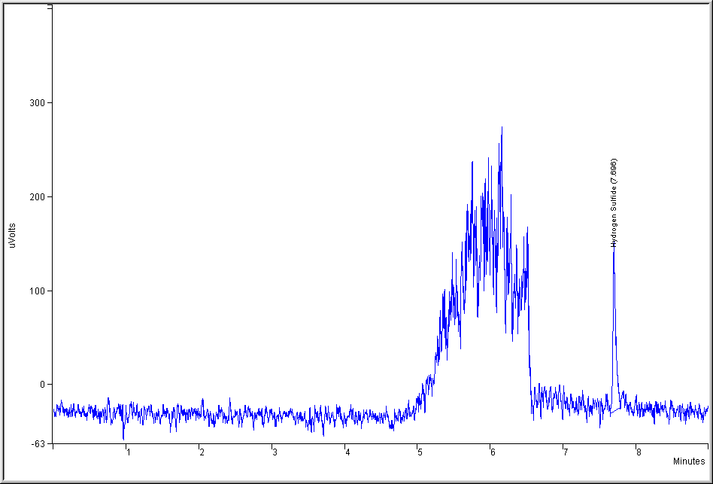
…and More Performance

Chromatogram of
0.3 ppb Hydrogen Sulfide Standard in Nitrogen

Conditions are same as above, except sample is 5 ml loading of 12 ppb standard.

Peak Height (μV) | Square Root of Peak Height
163 | 12.77
181 | 13.45
160 | 12.65
178 | 13.34
149 | 12.21
163 | 12.78
164 | 12.81
151 | 12.29
160 | 12.65
Average Square Root of Peak Height | 12.77
3 X RSD | 1.24
Concentration Equivalent to 3 X RSD | .029 ppb V/V

Measured Detection Limit – 0.03 ppb V/V
(3 X standard deviation of 9 runs at 0.3 ppb)

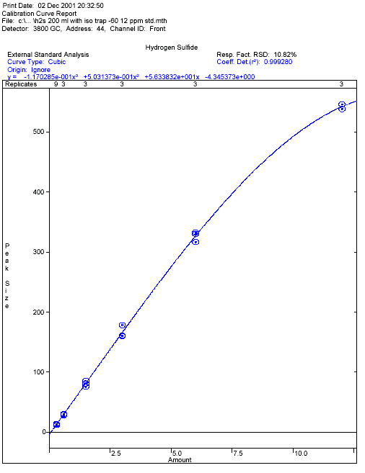
GREAT LINEARITY

A nice advantage of Mass Flow Controllers is that they can be used to generate multiple level calibrations, all based on a single standard. As the sample flow to the cold trap remains constant, the sampling time is varied to yield the different concentrations. Levels displayed above were analyzed in triplicate, except lowest level was repeated nine times.

The calibration graph above illustrates the linearity from 0.3 ppb to 12 ppb by setting the MFC to 25 ml/min and varying the sampling time from 0.2 minutes to 8 minutes.

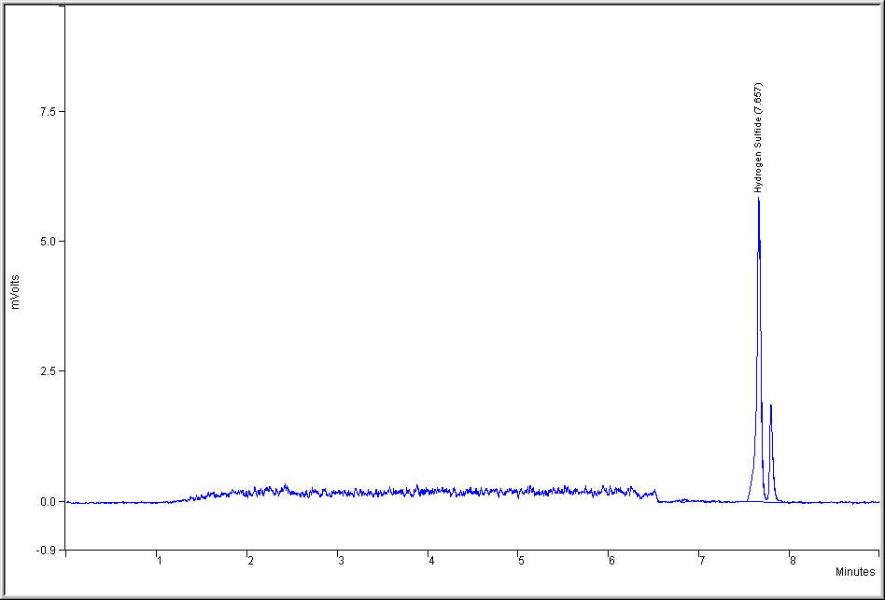
Chromatogram of Room Air
with 200 ml volume injected

Conditions are same as above, except sample is 200 ml loading of ambient air.
Unidentified peak adjacent to Hydrogen Sulfide has not been confirmed, but is potentially COS.

Measured concentration of Hydrogen Sulfide in Room Air is
1.45 ppb V/V ± 0.01 ppb V/V

System Diagram
He Carrier EFC

N₂ Purge
DFC
PFPD
MFC
Sample to MFC / Sample to Cold Trap then to MFC
16-position AutoSx
Sample Loading /
N₂ Purging
Cold
Trap
Trap
Isolation
Capillary
Column

System Specifications

Concentrator Trap
- Temperature range: -196 ºC to 450 ºC
- Maximum heating rate: >300 ºC/minute
- Maximum cooling rate: typically >400 ºC/minute
- Temperature stability: < 2 ºC after 1 minute stabilization
- Temperature overshoot: max. <10 ºC, typically <5 ºC
- Trap Cryogen usage: < 2 liters per sample
- Trap internal volume: ~600 microliters
- Trap material: proprietary, inert to sulfur compounds
- All trap settings controlled/monitored through GC with
platinum probe (RTD) and proportional controller (PID)
- Programmable in 5 temperature steps with holds

Automated Sampler
- Standard: 16-position
- Micro-electric actuation, self-aligning
- Independently controlled valve oven
- Maximum temperature limit: 225 ºC
- Sample position selected through workstation’s sample list
- Position documented in final report and archived with data
- Sample lines heated through control of system

Valving
- Fully automated under time-programmable control of GC
- Valves mounted in heated enclosures
- Micro-electric actuation, easy realignment
- Valco Valve Series CWE; max temperature: 225 ºC
- Valves can be turned on/off 21 separate event times
within single method

Sampling
- Sample loading volume user-selectable through
Lotus Consulting
310/569-0128 Fax 714/898-7461
email ebramstoncook@msn.com

5781 Campo Walk
Long Beach, California 90803
workstation from 2.5 ml to 1600 ml
- Samples in canisters or Tedlar bags can be handled
without hardware changes
- Loaded sample volume independent of canister pressure

System Performance
- Detection limit: < 0.030 ppb V/V
with 200 ml sample volume
- Typical area reproducibility - < 3 %
- Carry-over « 0.1 %
- Typical RT reproducibility - < 0.03 minutes

Pneumatics
- Column flow employs true Electronic Flow Controller (EFC),
not pressure control with computed flow
- Temperature-sensitive flow elements maintained at 45 ºC
- Flows automatically adjusted for atmospheric pressure

Column Oven
- Temperature range: -99 ºC to 450 ºC
- Temperature program rate: 0.1 ºC/min to 100 ºC/min
- Oven cool-down: 400 ºC to 50 ºC in 4.5 minutes
without cryogen
- Programmable in 7 temperature steps with holds
- Coolant timeout to preserve cryogen when system idle
- Negative temperature programming to save coolant
during sample loading

General
- GC display - Touch Screen [Very Thin Film Transistor (VTFT) and Wide Video Graphics Array (WVGA) with resolution 800 x 480, 9” (23 cm) diagonal size] eliminates keyboard “buttons”, for more robust operations
- Ethernet communications between GC and Workstation
- Line voltage for GC: 120 V, 20 amperes

